Capstone Project: Enterprise Azure Infrastructure Deployment

Project Requirements:

Resource Organization:

Create a Resource Group to contain all resources:

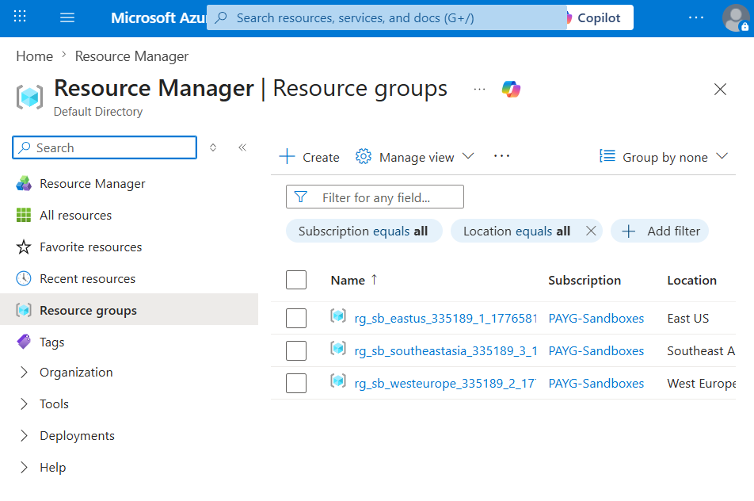

Networking Layer:

Create a Virtual Network (VNet)

Divide the network into Subnets: o Web Subnet o Application Subnet o Database Subnet

Apply Network Security Groups (NSGs) with proper rules

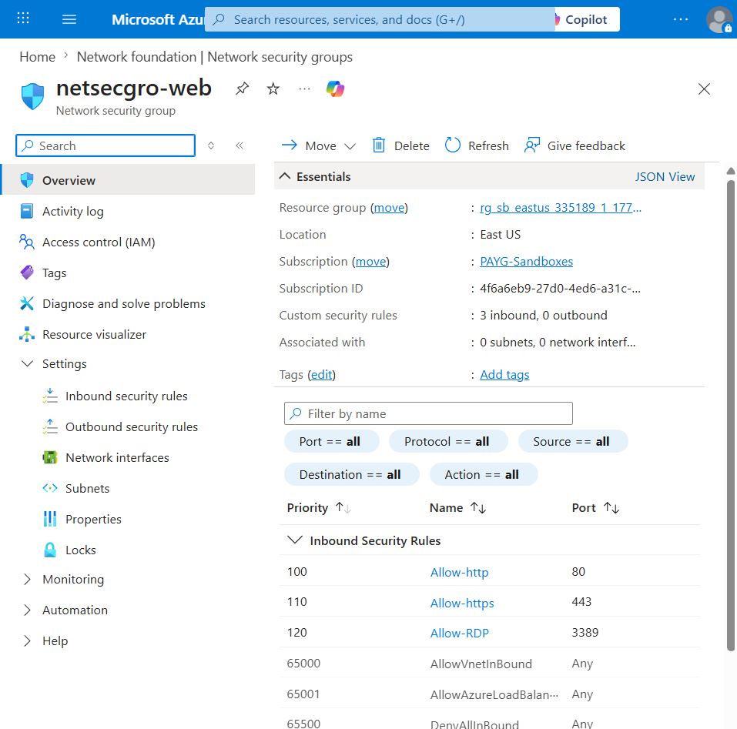

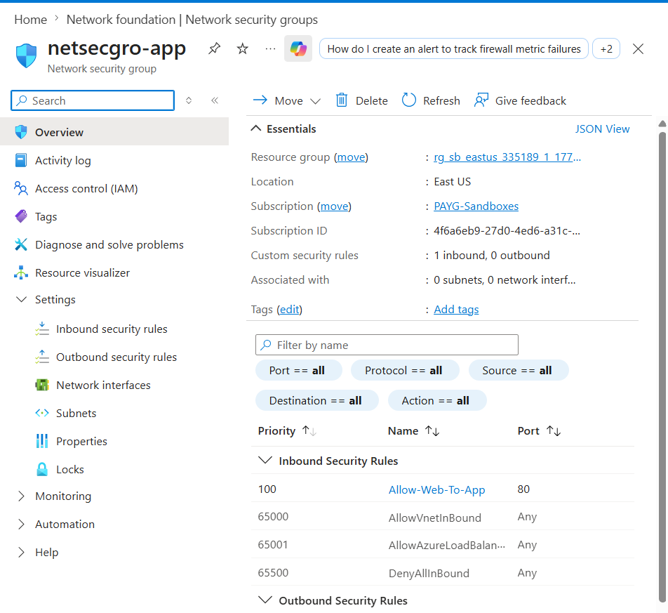
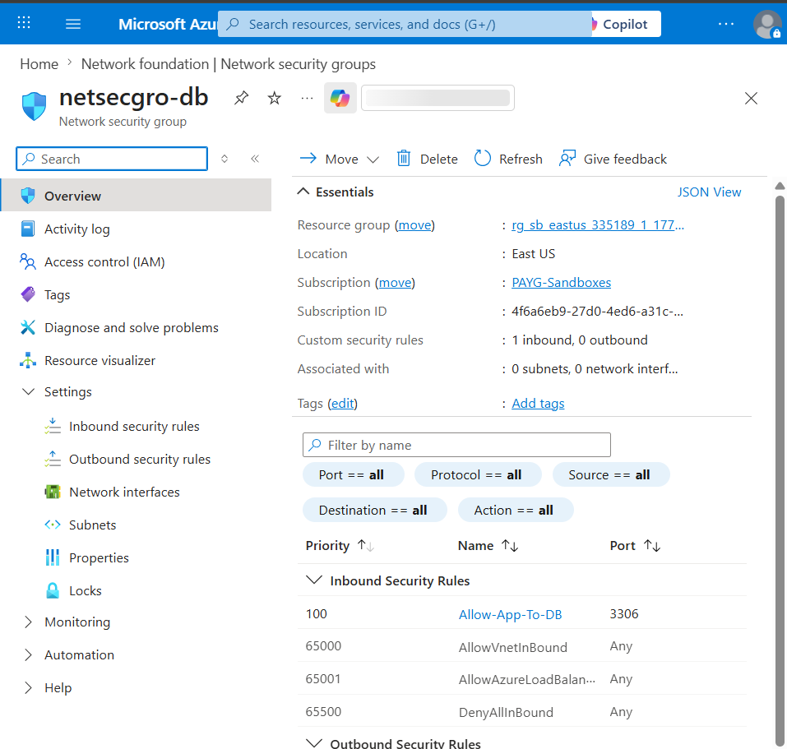

Compute Layer:

Deploy at least 2 Virtual Machines inside the Web Subnet

Install a Web Server (IIS / Nginx / Apache)

Ensure the servers are running and serving a web page

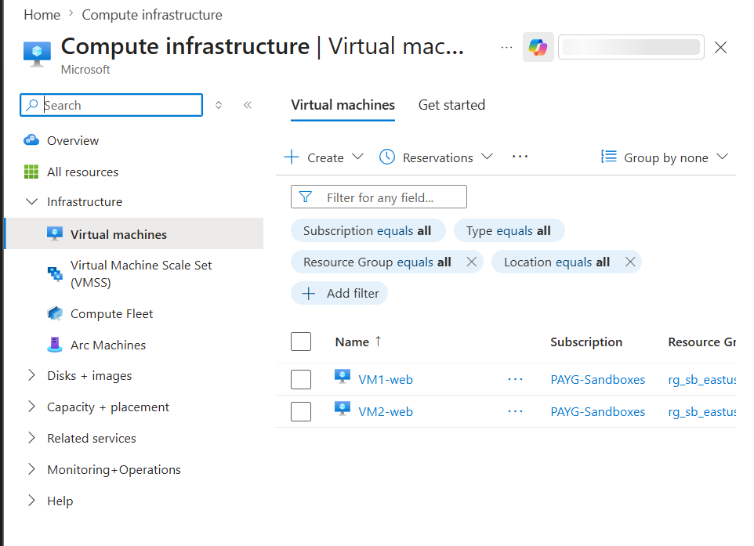

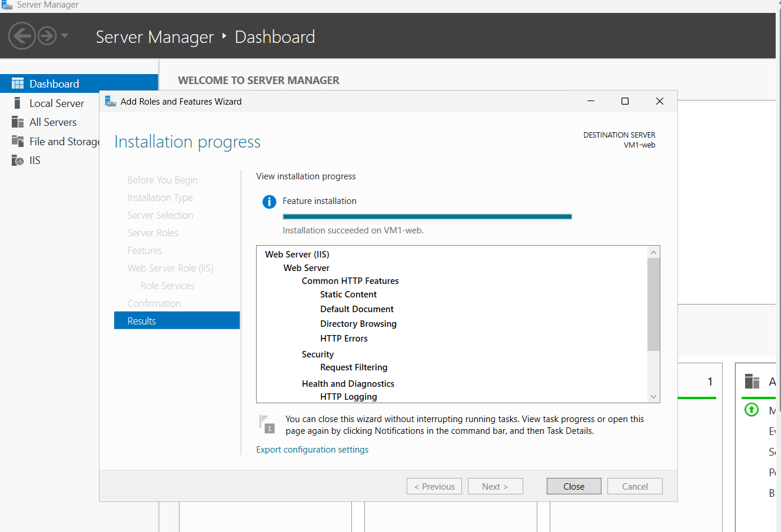
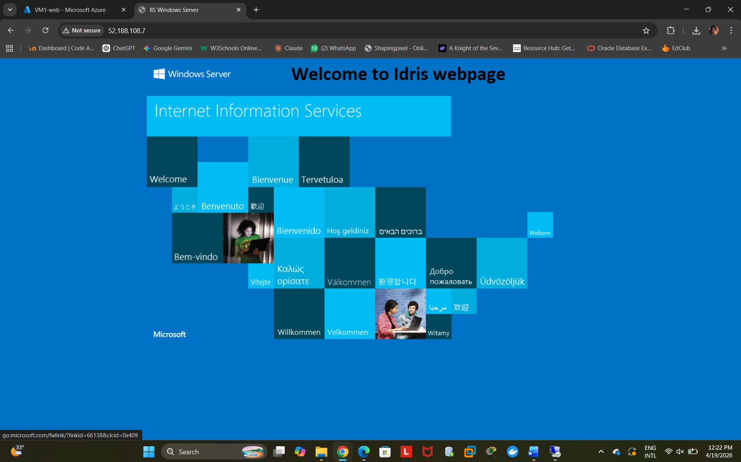

Load Balancing:

Configure a Load Balancer in front of the VMs

Distribute incoming traffic across instances
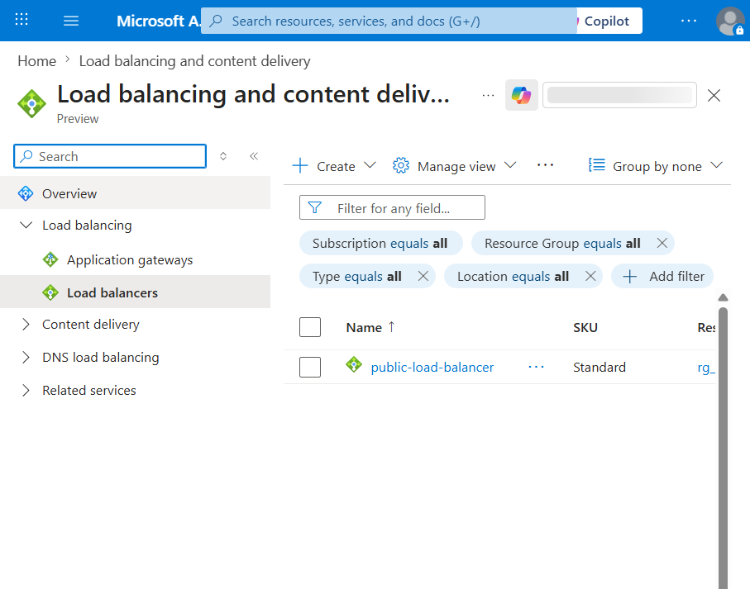

5. Data Layer:

Create an Azure SQL Database

Disable Public Access

Allow access only from within the Virtual Network
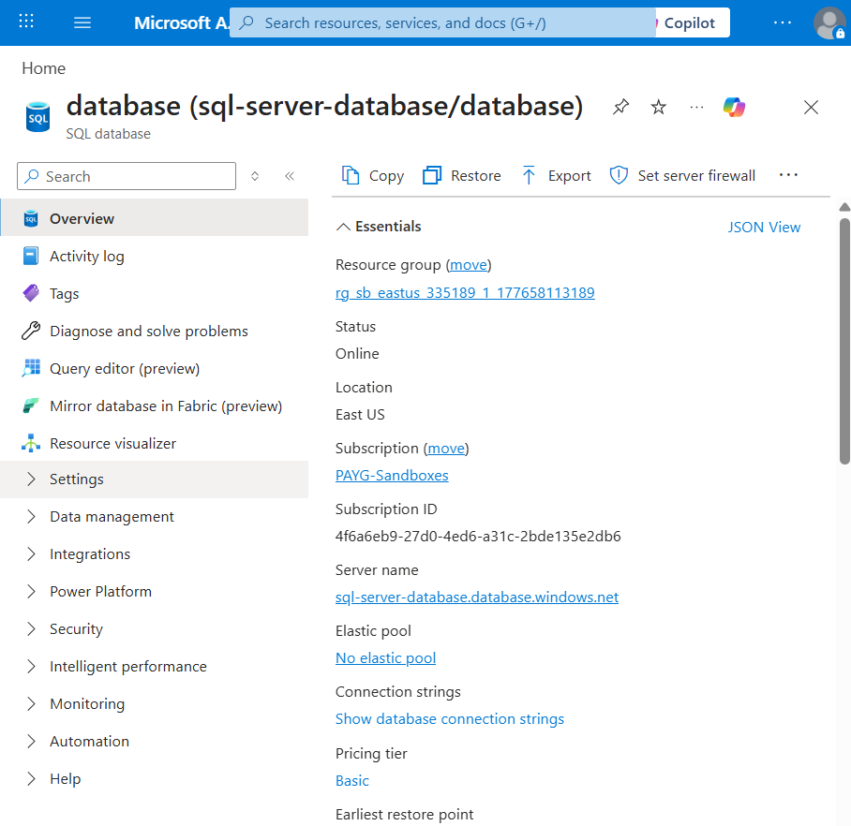

Security:

Use Azure Key Vault to store: o Credentials o Connection Strings

Implement: o Role-Based Access Control (RBAC) o Least Privilege Principle
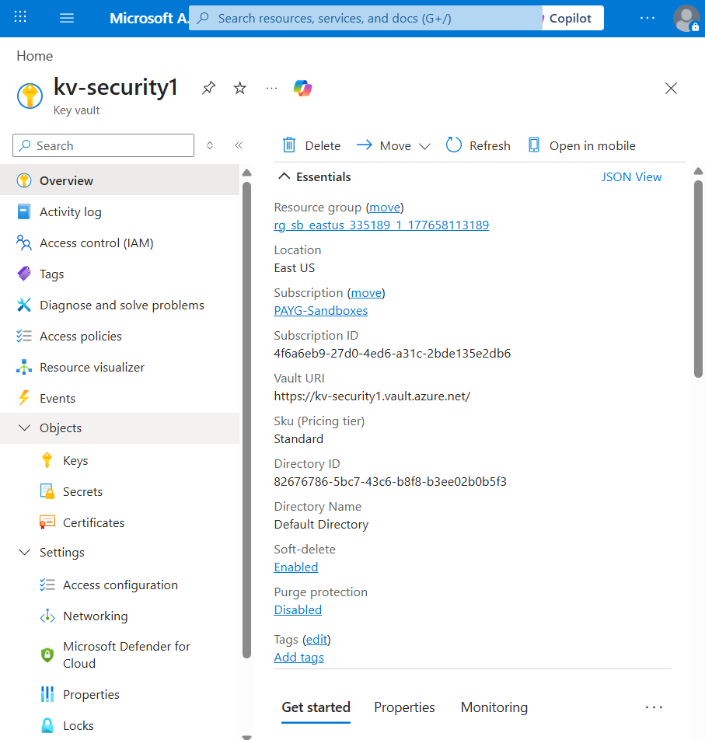

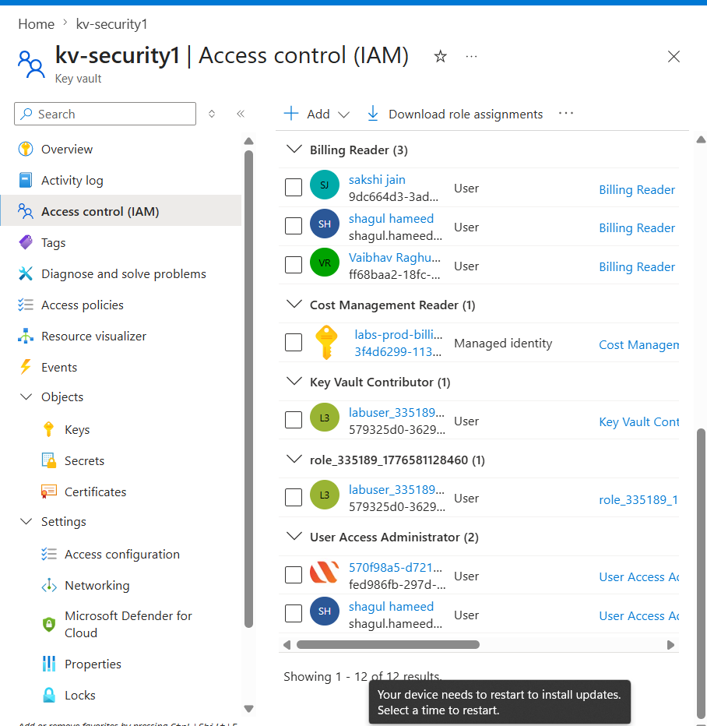

Monitoring & Logging:

Enable Azure Monitor

Enable Application Insights (if applicable)

Configure at least one Alert (e.g., high CPU usage)

